Art 101 Writing Assignment
School
2019
Overview
The installation of the Sleepwalker outside the Wellesley College brought up some controversy a few years back revolving around the intentions of the sculpture by the creator. However, according to the author of the sculpture, it was meant to portray a totally different meaning and provoke deep personal emotions.
The Sleepwalker sculpture has caused a lot of media debate due to the hyper-realistic sculpture which triggers a reaction from a number of people or groups in the society. The sculpture shown below has been installed in two different locations namely; New York City’s High Line, public walking space and one at the college campus in 2014.
The controversy of the Sleepwalker was astonishing to Matelli who felt that the public misinterpreted the message in the sculpture. Many people felt that the sculpture was made to trigger sexual emotions, gender or fear. The public also felt that the position of the sculpture in the City’s High Lane was not the best. Left in the snow, the sculpture appeared lonely, gory and appeared like a zombie in the wilderness. At the school grounds, the sculpture was viewed as a tool used to trigger the sexual feelings of the students in Wellesley College.
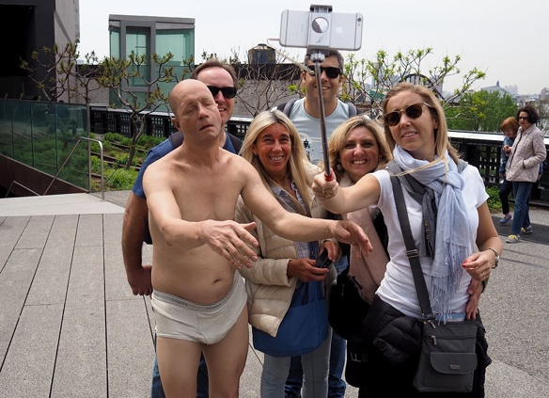
In the school, the sculpture which is seen on a daily basis by students makes them vulnerable to sex and sexual feeling which is not necessary for the school. The school is a learning institution and the sculpture does not capture that.
My position
The Sleepwalker sculpture has some ill motives. The school is not the right place for this sculpture. There are a number of reasons which makes me feel that the school is not the right place. For example, the school is a learning facility and ought to be respected. When nude images are placed in the compound of the school just like the sleepwalker, it triggers a lot of emotions in the school which is quite unnecessary. On the New York City’s High Line, which is a public walking, the sculpture can best fit in.
When located in school is looks weird but when in the streets, though weird too, it passes on critical information to the public on matters sex and gender. The interpretation in the school compound is totally different from what we expect. The creator of the sculpture Matelli missed it he took the sculpture to Wellesley College but it is in its rightful position on New York City’s High Line, a public walking space. At the public walking space, it is viewed as a fan base and the sculpture can be interpreted as ‘nothing serious’ which is okay.
The difference
When comparing the above sculpture with John Wilkes, by Butler, near the library, they are totally different with different information painted on them. Matelli’s sculpture seems to be real. It is a sculpture of a man with live sensational features such as the Y-front, underpants and the bald plate which makes one feel sexually aroused. I am sure the ladies can confirm that it is sexy. It appears to be real though not and triggers the best feelings in a fan base.
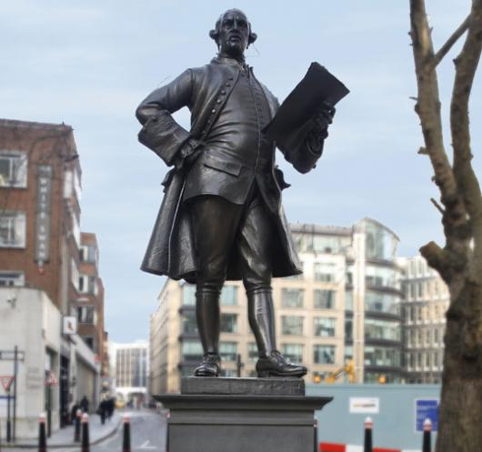
If Butler made his sculpture hyper-real as Matelli did, it would be a similar case. Actually, Butler’s one would be worse and highly condemned because the position is catchy and arousal. However, Butler’s sculpture is just fine the way it is and does not attract a lot of attention like Matelli’s. This would be the perfect sculpture for Wellesley College.

References
https://www.artsy.net/article/artsy-editorial-scandal-sleepwalker-foreshadowed-todays-culture-wars

